# 

# Final Year Project

# Introduction

Hamza Rauf

Shamail Aamir Khan

Eman Furrukh

Team Name:

VoyAIge

Team Logo:



Team Introductions:

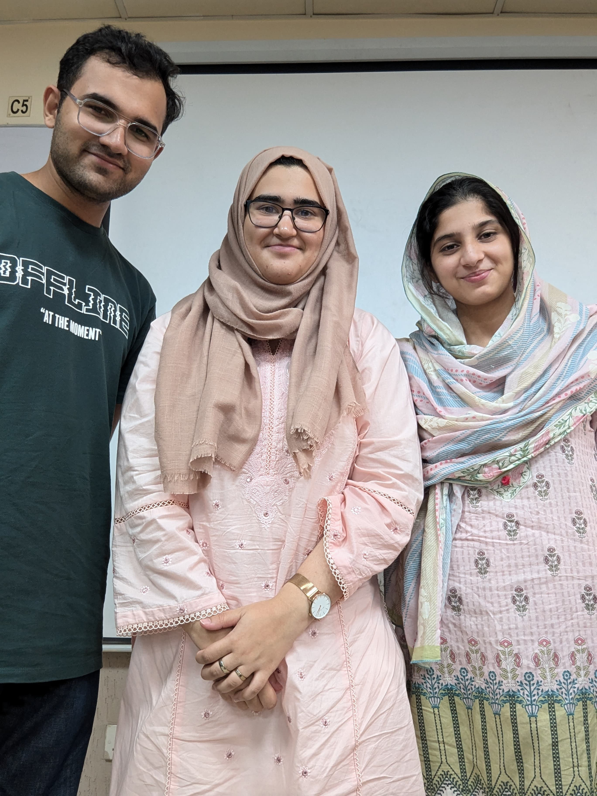

Member 1:

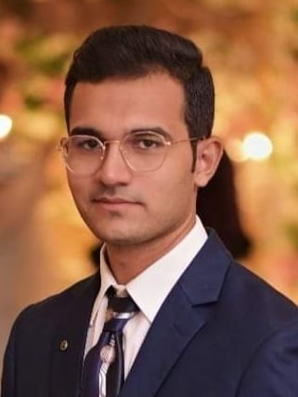I am Hamza Rauf, a computer science student at Fast University Islamabad. I am currently in my 7th semester. I am passionate about web development, and I strive to create innovative web solutions and continuously expand my technical skills. I’ve used programming languages such as C++, HTML, CSS, JavaScript, and Python.

Member 2:

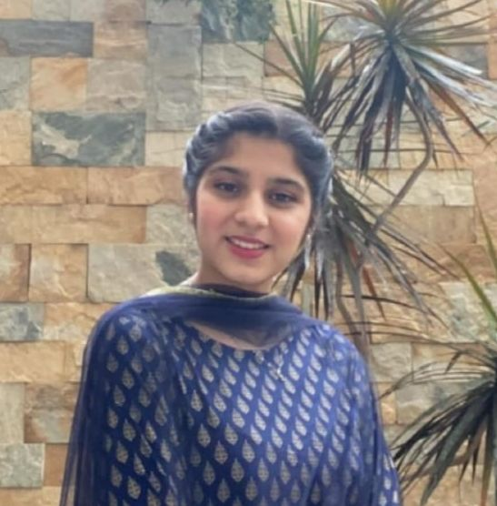I am Shamail Aamir khan, currently pursuing my degree at FAST. My academic journey has equipped me with a foundation in statistical analysis, machine learning, and data visualization. I have honed my skills in programming languages such as Python, C++, JavaScript. My field of interest is machine learning, NLP, image processing.

Member 3:

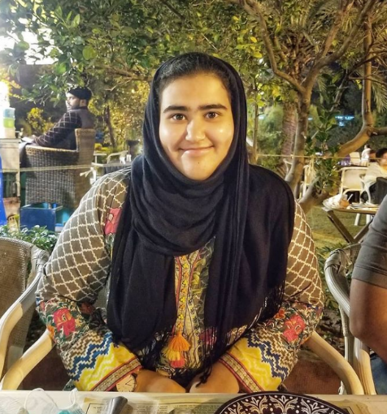Hello, my name is Eman Furrukh. I am a 4th year student studying at the National University Computer and Emerging Sciences (NUCES), Islamabad. I am currently pursuing a bachelor’s degree in data science where I’ve studied data visualization, statistical modeling, predictive modeling, NLP, neural networks using programming languages such as Python, C++, and R.

Github Names:

Member 1: HamzaRauf610

Member 2: shamail-123

Member 3: Eman-Furrukh

Team Agreements:

* Methods of Communication

WhatsApp, Google Meet, Email

* Communication Response Times

Same as above

* Meeting Attendance

Record maintained by Sir Bilal

* Running Meetings

When: 1 during the weekday, 1 during weekend

Where: Both Online and University.

Notes: Each person will take notes relevant to their task. Team leader notes down overall notes of other members whilst others take more specific notes. Team leader also notes down project progress.

* Meeting Preparation

Preparation is based off of each member summarizing what tasks they’ve completed and giving a demonstration.

* Version Control

Respect everyone’s opinions.

The majority wins approach in the case of disagreement.

Deadlines should be met.

* Contingency Planning

Team member drops out: Look for a replacement with similar domain interests.

Misses Meetings: Discuss with that member first, if member is not changing, consult with Supervisor.

Dishonest Member: Give them a chance to fix their ways, in case of no change, consult with Supervisor.